Education and Children's Services Scrutiny Committee
Meeting to be held on Tuesday, 18 January 2022

Electoral Division affected:
(All Divisions);

Corporate Priorities:
Caring for the vulnerable;

Children Looked After – Education, Employment and Training, Housing, School Transitions, and Health

Contact for further information:
Brendan Lee, Head of Service Looked After Children and Leaving Care,
brendan.lee@lancashire.gov.uk

Brief Summary

This report has been prepared for members of the Education and Children's Services Scrutiny Committee to provide a progress update in relation to work being carried out in three specific key areas:

- Children and Young People not in Education, Employment or Training
- Children, Young People and Housing
- Children, Young People and School Transitions

Recommendation

The Education and Children's Services Scrutiny Committee is asked to:

- Discuss the report and information presented.
- Consider any recommendations to further support the work of the Looked After Children and Leaving Care Service.

Detail

Introduction

Lancashire's Children's Permanence Service

Following the remodelling of Children's Services implemented on 04 January 2021, the Permanence Service was formed and is made up of the Children in Our Care teams and Leaving Care teams. The service focusses on supporting our children who are Looked After with a plan of permanence and our Care Experienced young people.

The ethos and culture of the service is very much based on ensuring that our children and young people are fully involved with every decision - no matter how big or small, and that our children and young people feel valued and are truly integral to shaping the services that we deliver for them.

The move to operate a functionality-based model of service delivery across our Children's Services has enabled the Permanence Service to develop areas of specialism that are showing to really benefit our children and young people and for social workers and personal advisors to be supported by a management team dedicated to our Looked After Children and Care Experienced young people.

This has introduced a degree of internal scrutiny and focus, which in turn has led to improved services that we are providing to our children and young people. Our data shows:

- we are seeing our children in a timelier manner;
- their case files are more accurate and up to date;
- we are responding to their education needs; and
- we are assessing their emotional wellbeing more frequently.

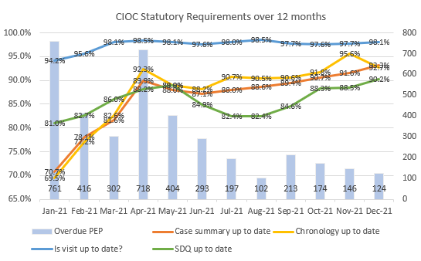

The above graph shows that on average we are visiting 97.4% of our children within statutory timescales, but currently this stands at 98.1%. Since August 2021, the services we deliver our children have improved month on month, in terms of ensuring their education needs and mental health needs are known, and key important documents are captured on their case file.

In addition, our audits are telling us that the quality of the work we are delivering to our children has much improved with 55% of audits graded as "Good".

The appointment of a Senior Project Lead and Practice Development Lead for the service has provided additionality which is proving invaluable and allowing the service to progress key developments, initiatives, and projects and pieces of work that contribute to improving outcomes for our children and young people.

Children and Young People not in Education, Employment, or Training

Current Data and Trends

Currently, there are more young people in education, employment, and training than during the same period in 2020. This is despite the impact of COVID-19 and lockdowns on education providers, students, and employees.

Cohort | EET 2021 | EET 2020 | UNKNOWNS 2021 | UNKNOWNS 2020
CLA (16+-17) | 80.4% | 79.3% | 0% | 8.5%
Care leavers  (18-20) | 52% | 47% | 1% | 2%

Strategy and Actions

In October 2020, the Corporate Parenting Board (CPB) approved the Children Looked After/Care Leavers Education, Employment, and Training (EET) Strategy and Action Plan.

An update on the actions is presented each CPB meeting to allow the board to monitor progress in EET, which is one of the board's key priorities.

An EET Strategy and Action Group meets regularly to assess progress and determine actions. To date this has been a joint group for Children's Social Care (Children in our Care and Leaving Care teams) and the Virtual School for Children Looked After and Care Experienced young people. The membership is to be extended to include representatives of further education colleges, employers, and other relevant services.

The key principles for the strategy are based on:

- Corporate Parenting responsibilities being owned and implemented by all relevant services, agencies, and partners.
- Key performance indicators are identified to measure progress of the impact the EET strategy and to enable the CPB to review and make relevant changes to the strategy if required to achieve the desired outcomes.
- All relevant services, agencies, and partners lead on, and are accountable for different sections and themes of the strategy according to their expertise.
- Raising aspirations and expectations both for our young people and all those that support them.

Examples of Key Performance Indicators and Current Data:

Every year 11 leaver young person to have an intended EET destination:

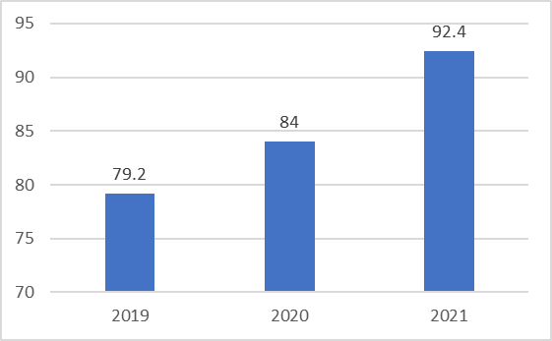

Number of young people attending university to increase:

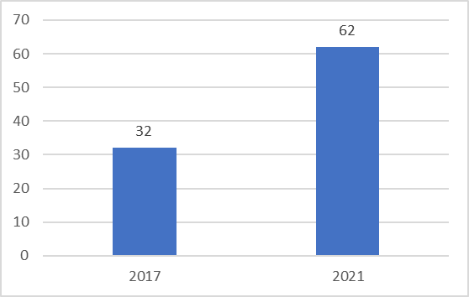

EET Support for Our Children in Our Care and Care Experienced Young People

- All our children who are Looked After have a social worker until they reach the age of 18 years, and in addition from 15¾ years an allocated personal advisor from the Leaving Care Teams. Supporting the young people to access and sustain employment is a high priority of the role of the personal advisor.
- All our children who are Looked After have a Personal Education Plan up to the age of 18 years. From September 2020, a bespoke Personal Education Plan template for children in key stage 5 (age 16+ to 18) was introduced. This provides a more age-appropriate template and a greater focus on stretching targets and aspirations and the support required to achieve these.
- All our children who are Looked After and our Care Experienced young people from 16 years to 25 years have a Pathway Plan, which supports their journey to independence including employment.

- The Virtual School 16+ lead officer tracks the progress and outcomes for our key stage 5 young people (age 16 – 18 years) and works closely with the colleges and training providers.
- The Virtual School has an Employment Support Team of nine qualified employment officers, who provide career information for all Lancashire Looked After Children in our schools from year 9 to year 11 (age 14-16). This includes advice on GCSE choices, career pathways, access to work experience and an action plan for each young person. This has resulted in an increase in the number of Year 11 leavers who have a planned EET destination.

The team support young people into training and employment as required, up to
25 years old, when referred by their social worker or personal advisor, or the young person themselves.

Work placement, apprenticeship, and employment opportunities are sourced from within Lancashire County Council and external employers.

To help support our young people who for several reasons are not yet ready for the world of work, a 16-week Preparation for Employment course has been devised and delivered by the team.

Summary of Outcomes:

- Between April 2020 and March 2021, the Employment and Support Team received 180 new referrals for Children Looked After/Care Experienced young people aged 16-25.
- 264 success events were held from April 2020 to March 2021, even though COVID prevented many activities from taking part. COVID has made it difficult for young people to start work, so many have chosen to gain skills at college and start work when businesses start to open.
- Two of our young people were supported into employment during April 2020 and March 2021.
- 83 of our young people have had a funded employment opportunity so far April 2021 to October 2021.
- Young people who have special educational needs and have an Education, Health, and Care Plan also have support from the Inclusion Service, who have a named officer to support EET for their young people.
- A range of activities and events are held jointly with universities and colleges to support access to higher education. The Empower Academy programme provides a programme for year 9 to 11 to learn about university life and opportunities.
- A regular forum for Further Education providers meets with the Virtual School post 16 lead officer and Children's Social Care officers, to further improve our partnership working and develop their 'offer' of support for our young people.

Children, Young People and Housing

A number of significant and positive steps forward have been taken over the year in relation to our Care Experienced young people and housing. However, this is balanced against key challenges that our Children in Our Care face, noting that these are national challenges and not Lancashire specific.

Care Leaver Accommodation Protocol

Following consultation with all twelve districts, providers, registered social landlords, the Department for Levelling Up, Housing and Communities (formerly Ministry of Housing, Communities and Local Government) and our young people, the Permanence Service has developed a protocol to ensure all our Care Experienced young people can have their own home when they are ready. The protocol is undergoing some final amendments ready to be launched in the New Year. We have a county councillor lead for this piece of work who will support us to embed this protocol within the districts. The success of the protocol will be reviewed at the Corporate Parenting Board.

Lancashire House Project

With the support of our Care Experienced young people, we have successfully secured acceptance on to the National House Project. Nationally, the project has supported 250 young people, with 141 of these young people living successfully within House Project properties and no evictions or tenancy break downs having occurred.

The House Project takes an innovative and ground-breaking approach to enabling young people to secure their own home and independence. It works on cooperative principles through which adults and young people in and leaving care, work together to refurbish properties that become their homes and build a long-term community of support.

As one of only thirteen local authorities that have been successfully accepted onto the programme, this is seen as a real achievement for Lancashire and for our young people - and will make a real positive difference for our young people.

The House Project will be staffed by one coordinator and two facilitators with an aim of securing ten social housing properties for ten young people in the first co-hort. Young people will be able to take part in the learning programme which is accredited by AQA and is linked to the ORCHIDS psychological framework.

We are currently at stage 3 (Project Set-up) of the implementation process. We are looking to recruit the staff early next year and identify a base for the project.

Project implementation (first group of young people) is due to take place at the end of year 1.

Foster Care Sufficiency

The proportion of our Children Looked After living in a foster home has steadily increased throughout 2021, rising from 63.6% in January to 64.3% in November. This increase is due to a significant reduction in the number of our children in our care, rather than an increase in the number of children living in foster homes. Since the start of the year, there are 95 less Lancashire children in a foster home, with reduced numbers delivered by both the in-house fostering service and Independent Fostering Agencies (IFA). However, the number of IFA foster homes has fallen more significantly and accounts for 70% of the overall fall in 'non-connected' foster homes.

The challenge of finding foster homes has increased in recent months, with many IFAs reporting that they do not have any carers available. This is not a Lancashire specific issue, but an issue across the region and nationally. The shortage of available carers has led to a number of our children who have a plan for fostering having to be placed in a children's home. Work to secure these children a foster home is and continues to be a priority for the Permanence Service, our colleagues, and partners.

Children's Home Sufficiency

The number of our Children in Our Care living in a children's home has remained fairly consistent throughout most of 2021. However, there has been a sharp rise in numbers in the last few months, 8 more in October and 15 more in November. There are now 211 children living in a children's home, compared to 185 at the start of the year. The proportion of our children living in a residential children's home has significantly increased from 8.8% in January to 11% by 30 November, as has the cost, with the average weekly cost now £415 more than it was at the start of the year.

Currently, the county council is largely reliant on agency providers for our children and young people with more complex behaviours/needs. Where agency providers are not prepared or able to deliver regulated provision for a young person, the county council can be left with no choice but to have to place children in unregulated provision. Since September 2021, however, it has become unlawful to place any child aged under 16 in unregulated provision. In response, we have sought to increase in-house provision to meet need.

In January 2021, Cabinet agreed the expansion of our in-house children's residential service from 11 homes to 15 homes, which includes two additional smaller homes able to care for children with more complex behaviours/needs and another regulated
short-term crisis home. The county council has recently been successful in an application to the Department for Education to secure capital funding to develop a further short to medium term home for children with the most complex behaviours/needs. Work to develop the five new in-house homes is underway.

Children, Young People and School Transitions

This relates to two situations:

- Normal transition points when progressing through school from nursery to primary school and primary school to secondary school.

- For all children this can be challenging and often more so for vulnerable children.
- To reflect this, the new Personal Education Plan includes a section specifically on plans and support for any planned transition. This emphasises the need for planning and preparation for the move including timely communication between the schools/settings and expectation that a representative from the new school would attend the final Personal Education Plan meeting before the move to ensure appropriate support is in place.
- There is a current focus on 'school readiness' as there is an awareness that vulnerable children can have less well-developed skills that help them settle and thrive into school. This can relate to speech and language, personal care, and social skills.
- There is an ongoing review of the number of our Looked After Children aged
2+ years who attend a nursery setting. Children's Social Care and the
Virtual School have worked closely with the Early Years Funding and Sufficiency team to provide more accurate data, which can inform strategy and actions. Evidence demonstrates that children who attend nursery settings are better prepared to enter reception.
- A recent campaign to promote the Early Education Funding for two year olds offer to eligible families has been launched. The campaign commenced on
13 December 2021 and will run through January 2022.
- The most recent data below is shown for Summer 2021, which shows a decrease from Spring 2021.

 | Total No. of CLA 2-Year-Olds | No. of  Children Taking up funded hours | % | Total No. of CLA - & 4-Year-Olds | No. of  Children Taking up funded hours | %
CLA | 74 | 37 | 50.0 | 61 | 41 | 67.2
- The Virtual School provides training sessions for foster carers and adopters on supporting children with transitions and these have been well attended and with positive feedback.
- Training provided for carers on supporting speech and language skills and sensory development.

- School moves related to becoming Looked After, impact of home placement breakdowns, transferring to special schools or alternative provision

Guidance requires for children to remain in their current school when they become Looked After, as far as possible so they continue to have education stability. School moves for young people in the later stages of secondary school should especially be avoided except in exceptional circumstances due to the potential impact on exam attainment. Research shows that school moves often have a detrimental impact on progress and attainment. However, the impact can be mitigated against by good preparation and communication between schools, social workers, and carers.
It is not always possible to avoid a school move due to:

- the location of the initial home the child lives in is too far to travel to the school. This will include those children who are placed out of Lancashire and due to the size of our local authority, it is often not practical for a child to travel back to their school when they have moved home even within the authority.
- further home moves which may be linked to home breakdowns.
- the breakdown in the school placement and/or decision that a school move is in the child's best interest e.g. could be a move to alternative provision or special school.

Most Recent Data: To Date for All Current Looked After Children

- 46.2% of primary school pupils remained in one school throughout their primary education since coming into care and 81% have either remained in their original school or had just one move.
- 20.9% of secondary school pupils remained in one school since coming into care and 44.3% have either remained in their original school or had just one school move.
- The increased school moves for secondary pupils reflects the fact that for this cohort entering care often includes a home placement further from their current school, an increased risk of potential home placement breakdowns due to complex needs, and therefore an increased in potential of being placed in another local authority.
- The % of children experiencing multiple school moves i.e. more than four moves had decreased. Secondary age group is 11.8% and primary age group 1.9%. However, we need to continue to reduce this % especially for the secondary cohort of young people.

Next Steps – What Are We Doing to Continue to Improve Employment, Education, Housing and Transitions for Our Children and Young People

The vision for our children and young people is for them to be safe, healthy, and achieve their full potential. To achieve this, our children require stable high-quality homes, near to their school, with continuity of professionals providing support. We have identified common causal factors that contribute to our children and young people not being in Employment, Education or Training, which include:

- Home stability
- Type of home (children in foster care have improved outcomes)
- Changes in social workers
- Disruption during high school
- Poor Mental Health
- Pregnancy and parenting

In response, the following work is planned throughout 2022:

- Campus days for young people and staff will be held at local universities.
- Permanence tracking is to be reviewed and improved processes implemented.
- Lasting Home Panels will be launched.
- Escalation processes are to be developed for when our children refuse to attend school.
- An alternative provision strategy is to be developed.
- All our children will have an achievable Intended Destination in-line with their abilities and wishes and feelings and this will be embedded in a multi-agency support plan.
- Employability training/coaching will be delivered to all personal advisors.
- A strategy and tracking system will be implemented to ensure all Year 10 and Year 11 Looked After Children are provided with careers advice.
- A strategy and tracking system will be implemented to ensure all Year 8 and Year 9 Looked After Children are provided with support around options.
- A review of the financial entitlements for practical and financial support for our young people attending top tier universities is to be undertaken.
- Our ambition is that all corporate co-parents, partners, and commissioned services will provide permanent positions and/or apprenticeships to our care experienced young people.
- The Leaving Care Service Plan to keep in touch with every young person in new employment at least monthly for the first six-months of employment with a focus on sustaining employment.
- The Employment Support Team Plan to keep in touch with every young person in a new employment at least weekly for the first eight-weeks and to continue providing a service to the young person for at least six-months to address any employment issues, where the Employment Support Team have supported them into employment.
- A peer support approach to EET is to be explored.
- Three monthly taster days will be made available to every care experienced young person.
- A Corporate Parenting Housing Framework is to be developed to ensure young people have access to a range of supported and/or permanent housing provisions which is suitable, affordable, and in an area which has good support networks and access to community services.
- Work will continue to reduce the number of agency social workers required, and increase the permanent recruitment, to create a more stable workforce.
- The Lancashire House Project will be launched for the first cohort, ten young people.

Consultations

N/A

Implications:

This item has the following implications, as indicated:

Risk management

Finance

There are no financial implications.

Local Government (Access to Information) Act 1985

List of Background Papers

Paper | Date | Contact/Tel
NA
Reason for inclusion in Part II, if appropriate
NA

